Name: Linguistics 1010 - Week 2

Discussion Section:

Make-Up Assignment

For this assignment, use the notes from the lectures to help you. The phoneme symbol chart from Lecture 2 and the consonant and vowel charts from Lecture 3 will be particularly helpful. You are not expected to memorize the charts, so do not be afraid to reference them!

1. **Place of Articulation**

Each row below is labeled with a place of articulation. Your goal is to determine if the words in the row contain a consonant that has that place of articulation. To do this, you will need to determine the place of articulation for each consonant in each word. Then simply type “yes” or “no” in the box – “yes” if the word contains a consonant with that place of articulation, “no” if the word does not contain a consonant with that place of articulation. We have added the IPA transcription of the words to help you (because English orthography does not always correspond to the actual phonemes).

|  |  |  |  |  |
| --- | --- | --- | --- | --- |
| **Bilabial** | Debt  [dɛt] | Lamb  [læm] | Psychic  [saɪkɪk] | Bank  [bæŋk] |
| **Labiodental** | Phase  [fez] | Rough  [rəf] | Live  [lɪv] | Life  [laɪf] |
| **Interdental** | Bathe  [beð] | Thick  [θɪk] | Tilt  [tɪlt] | Dearth  [dərθ] |
| **Alveolar** | Them  [ðɛm] | Scare  [skɛr] | Dark  [dark] | Hymn  [hɪm] |
| **Palatal** | Cheat  [tʃit] | Chaos  [keas] | Jeans  [dʒinz] | Shave  [ʃev] |
| **Velar** | Knife  [naɪf] | Wreck  [rɛk] | Wrote  [rot] | Grape  [grep] |
| **Glottal** | Chrome  [krom] | Heat  [hit] | Birdhouse  [bərdhaws] | Anchor  [æŋkər] |

1. **Manner of Articulation**

This is the same as the previous activity, but this time dealing with manner of articulation. In each row, determine if each word contains a consonant with the manner of articulation at the beginning of the row. Type “yes” or “no” in each box. Again, we have provided IPA transcription to help you.

|  |  |  |  |  |
| --- | --- | --- | --- | --- |
| **Stop** | Plumber  [pləmər] | Fast  [fæst] | Fasten  [fæsən] | Canned  [kænd] |
| **Nasal** | Master  [mæstər] | Column  [kaləm] | Sting  [stɪŋ] | Sick  [sɪk] |
| **Fricative** | Island  [aɪlənd] | Aisles  [aɪlz] | Shore  [ʃɔr] | With  [wɪθ] |
| **Affricate** | Christmas  [krɪsməs] | Chimney  [tʃɪmni] | Jealous  [dʒɛləs] | Conscious  [kanʃəs] |
| **Glide** | Jeans  [dʒinz] | Cube  [kjub] | Flower  [flawər] | Sword  [sɔrd] |
| **Liquid** | Wrap  [ræp] | Rap  [ræp] | Chalk  [tʃak] | Lit  [lɪt] |

1. **Voicing**

Indicate (e.g. highlight or change to bold) which words **START** with a **VOICED** consonant. If you are not sure, put your hand over your throat where your vocal folds are and feel for vibration when you make that consonant. Remember: *Voiced* consonants are consonants where the vocal folds vibrate during the obstruction. *Voiceless* consonants do not have vibration during the obstruction. We have not provided the IPA transcriptions for these words… so if you try to look up the answer in the charts (rather than feel your own vocal folds), you will have to do some thinking about which consonant the word begins with (English orthography is not reliable for this).

**Focus on the initial sound of the word**

1. People
2. Yellow
3. Banana
4. Weather
5. Tomorrow
6. Red
7. Thinking
8. Sea
9. Gator
10. Crocodile
11. Hanger
12. Never
13. Quick
14. Vase
15. Gentle
16. Them
17. Consider how the sounds represented by the bold letters are produced in the following words. Which features distinguish the sounds from each other? Do they differ by the place of articulation? Manner of articulation? Voicing? A combination of features? Type the feature or features after the colon. (Again, we have not provided IPA transcription, so you will have to either feel the articulation in your pronunciation, or think carefully about what the consonant is before looking it up in the charts.)
18. **P**ump 🡪 **B**ump:
19. Dru**m** 🡪 Dru**g**:
20. Fli**p** 🡪 Fi**ll**:
21. **T**ear **🡪 D**ear:
22. Lea**v**e 🡪 Lea**d**:
23. **F**ling 🡪 **Z**ing:
24. **P**lain 🡪 **M**aine:
25. **S**ip 🡪 **Z**ip:
26. **Formants**

Here are some time-frequency spectrograms of vowels in English. These spectrograms are very similar to the ones we saw in class (the “EQ” spectrograms), but they add time the plot. Time is on the x-axis (going from left to right), frequency is on the y-axis (with higher frequencies higher on the y-axis, and lower frequencies lower on the y-axis), and amplitude is indicated by the darkness of the bands (black is higher amplitude, light gray is lower amplitude). The goal in this exercise is for you to see a different representation of formants from the one in class, and to practice identifying formants.

1. We have indicated the three formants for two vowels below by putting red arrows next to the formant. Your task is to label each formant as F1, F2, or F3 (the first, second, and third formant). That really is all you have to do. You should be able to do this based on the relative definition of F1, F2, and F3 given in lecture. Type the label on the lines next to the arrows.

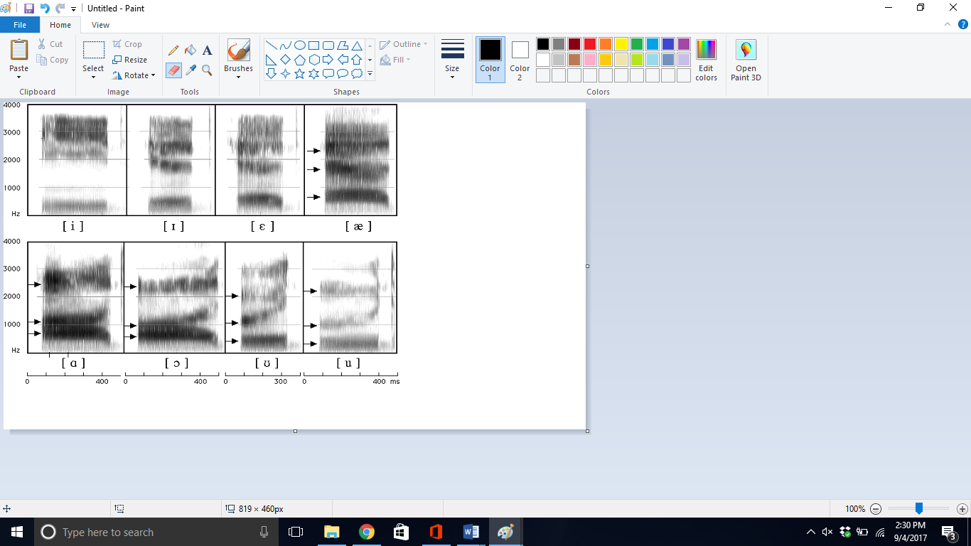

________

________

________

________

________

________

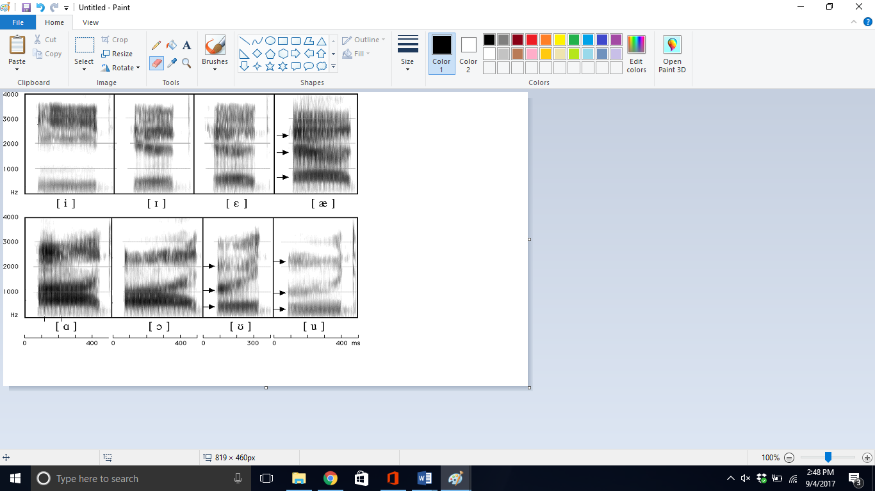

(as in f*ee*d) (as in h*i*d)

1. We have provided spectrograms of two more vowels below. Your task here is to mark the formants themselves. You can either put a red arrow next to them, or even circle them. There are three (F1, F2, and F3). You don’t have to add the F1/F2/F3 labels, just mark them with an arrow or circle. You should be able to do this based on the definition of formant given in lecture, and your new knowledge about how these plots indicate frequency and amplitude.



(as in f*a*ther) (as in c*au*ght)

1. **Fill in the Blank**

The larger the amplitude of a wave, the ______________ the sound is perceived. The lower the amplitude of a wave, the ______________ the sound is perceived.

1. **Short Answer**

During the LING 1010 lecture, we talked about evidence that leads linguists to believe that the representation of phonemes is not in terms of formants, but rather they have proposed that phonemes are represented as a combination of articulatory features. Describe one piece of evidence for this, and indicate how it makes that argument. Type your answer (one paragraph is sufficient) below.